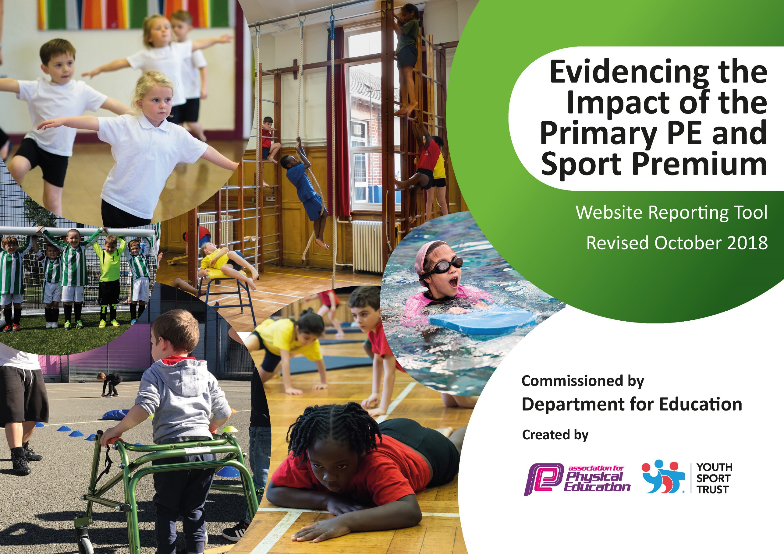
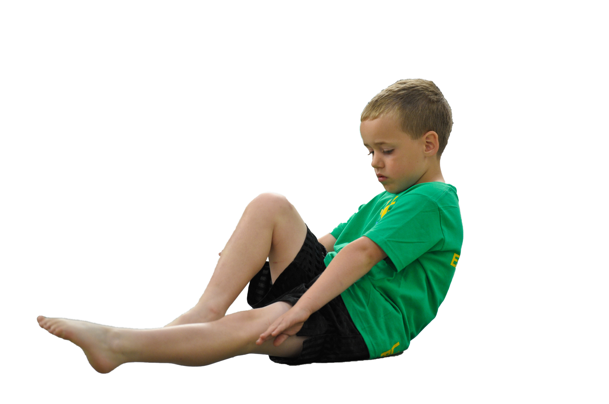
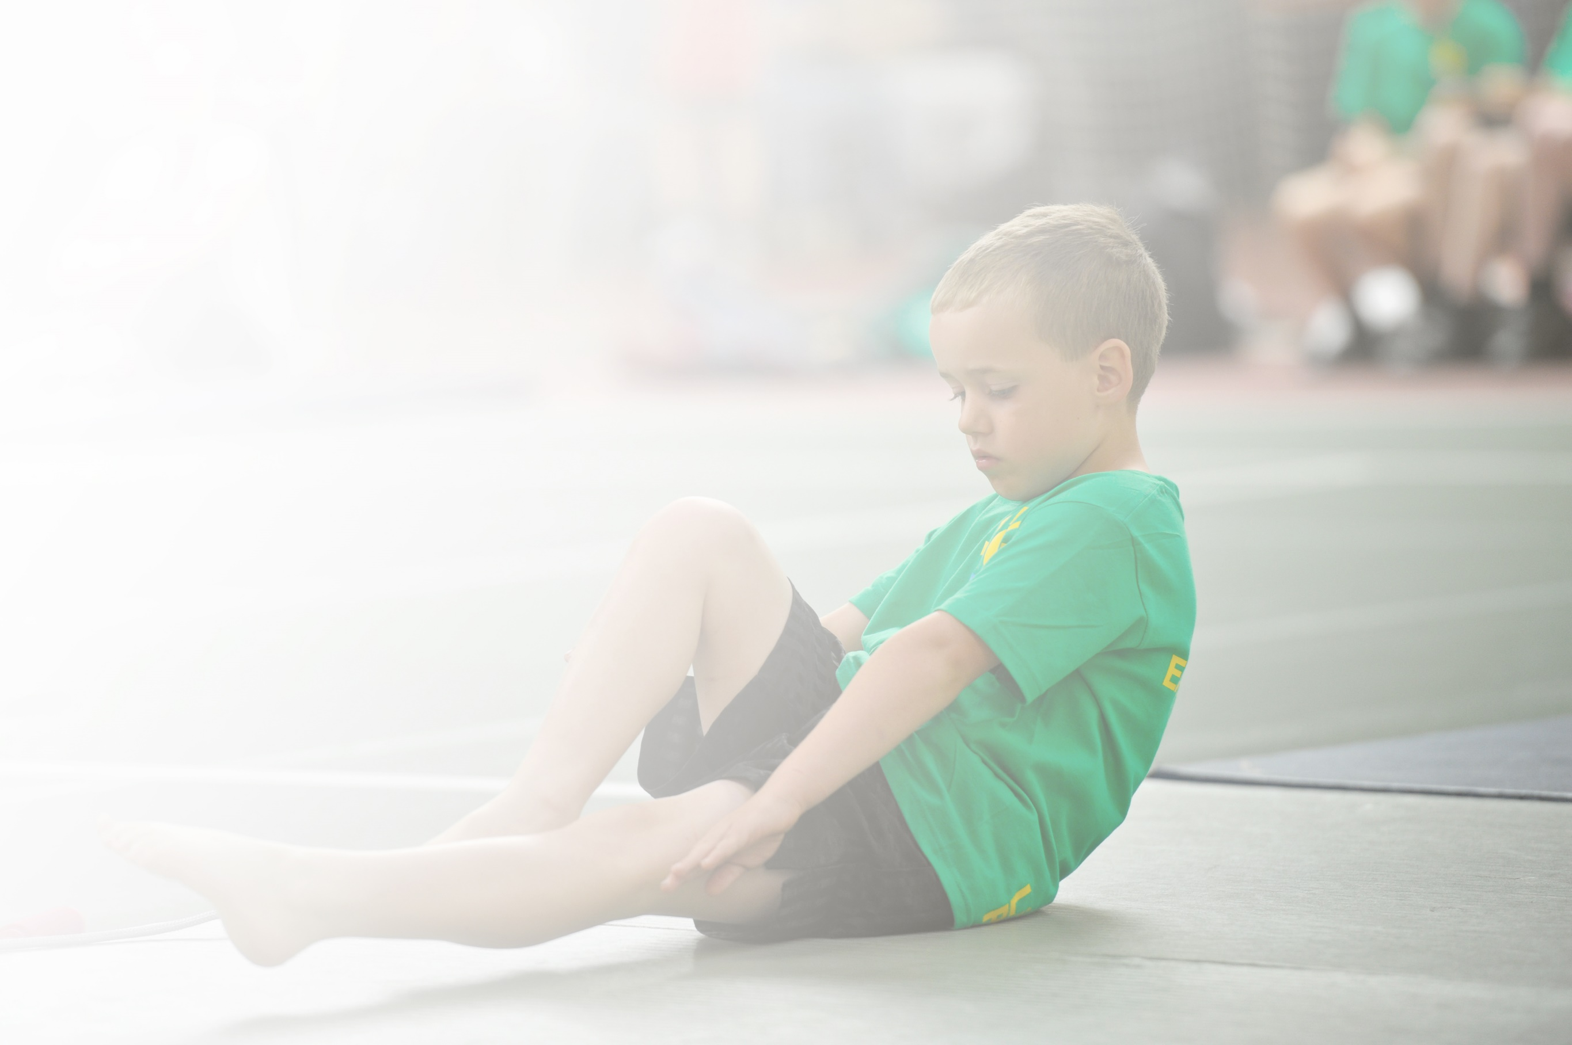
Schools must use the funding to make additional and sustainable improvements to the quality of Physical Education, Sport and Physical Activity (PESPA) they offer. This means that you should use the Primary PE and Sport Premium to:

- Develop or add to the PESPA activities that your school already offer
- Build capacity and capability within the school to ensure that improvements made now will benefit pupils joining the school in future years

Please visit gov.uk for the revised DfE guidance including the 5 key indicators across which schools should demonstrate an improvement. This document will help you to review your provision and to report
your spend. DfE encourages schools to use this template as an effective way of meeting the reporting requirements of the Primary PE and Sport Premium.

We recommend you start by reflecting on the impact of current provision and reviewing the previous
spend. Under the Ofsted Schools Inspection Framework, inspectors will assess how effectively leaders use the Primary PE and Sport Premium and measure its impact on outcomes for pupils, and how effectively governors hold them to account for this.

Schools are required to publish details of how they spend this funding as well as on the impact it has on pupils’ PE and sport participation and attainment by the end of the summer term or by 31 July 2019 at the
latest.
We recommend regularly updating the table and publishing it
on your website throughout the year, as evidence of your
ongoing review into how you are using the money to
secure maximum, sustainable impact. To see an
example of how to complete the table please
click HERE.

Support for review and reflection - considering the 5 key indicators from DfE, what development needs are a priority for your setting and your students now and why? Use the space below to reflect on previous spend, identify current need and priorities for the future.

Key achievements to date: | Areas for further improvement and baseline evidence of need:
Hartford Primary School is currently applying for a third Platinum Award for PE. This means that PE has a high priority in school and that we provide a range of activities for all children to access.  At Hartford we aim to give children of all abilities access the chance to access activities that meet their needs. Our most able children are given high-quality coaching that leads to sporting success. This year we have reached the County Final in mixed football, girls football (won), mixed cricket, girls cricket, indoor athletics, tag-rugby (won), tennis and gymnastics.  All children have high-quality PE lessons and the chance to be active for at least 30 minutes every school day. | Use PE for whole-school improvement.  Target children using a questionnaire to ensure Pupil Voice is at the centre of what we offer.  Target specific groups such as Gifted and Talented children, the least active etc to ensure their needs are met.

Meeting national curriculum requirements for swimming and water safety | Please complete all of the below:
What percentage of your current Year 6 cohort swim competently, confidently and proficiently over a distance of at least 25 metres?  N.B. Even though your children may swim in another year please report on their attainment on leaving  primary school. | 93%
What percentage of your current Year 6 cohort use a range of strokes effectively [for example, front crawl, backstroke and breaststroke]? | 93%
What percentage of your current Year 6 cohort perform safe self-rescue in different water-based situations? | 0%
Schools can choose to use the Primary PE and Sport Premium to provide additional provision for swimming but this must be for activity over and above the national curriculum requirements. Have you used it in this way? | Yes

Action Plan and Budget Tracking
Capture your intended annual spend against the 5 key indicators. Clarify the success criteria and evidence of impact that you intend to measure to evaluate for students today and for the future.

Academic Year: 2018/19 | Total fund allocated: £19,380 | Date Updated: 15th July 2019
Key indicator 1: The engagement of all pupils in regular physical activity – Chief Medical Officer guidelines recommend that primary school children undertake at least 30 minutes of physical activity a day in school |  |  |  | Percentage of total allocation:
 |  |  |  | 35%
School focus with clarity on intended impact on pupils: | Actions to achieve: | Funding allocated: | Evidence and impact: | Sustainability and suggested next steps:
All pupils at Hartford Primary School completed a questionnaire during the Autumn Term. This allowed the school to see how active children are inside and outside of school and plan to ensure that children are meeting the goal of being active for at least 30 minutes every school day. | Plan, write, complete and analyse the questionnaire with all children.  Target any areas that the questionnaire flags up and target the least active children.  Purchase Maths of the Day to improve activity levels in maths.  Continue to subscriber to 5 a day fitness, GoNoodle, Cosmic Kids Yoga and Super Movers and monitor their use.  Monitor activity levels in PE lessons and provide training to improve this area.  Run a staff meeting to remind staff of the current research in this area and the expectations.  Hire a new member of staff to deliver an active breakfast club, after-school clubs and to target the least active children during the school day.  Extra after-school clubs were paid for by the funding to ensure that the non-attenders had clubs they requested. | £170  £495  £200  £245  £5088  £600 | The questionnaire gave excellent data which we spent time analysing. The inactive groups identified were specifically targeted by Mrs. Middlebrook. A good example of this was the Active Story Club. A group of Y2 children were identified as not enjoying PE, being less able and not being active outside school. Training was provided on the Active Story Club course. Mrs. Middlebrook then delivered this to the children. They reported an increased enjoyment of physical activity and increased activity levels.  Children at Hartford have very active PE lessons, run the Golden Mile each week and use online tools such as 5-a-day fitness to make sure they are active for at least 30 minutes.  Extra clubs in cricket, multi-skills, fencing, judo, netball, rounders and tri-golf. This increased participation in after-school clubs up to 92% | The questionnaire can now be used every year to identify target groups and track impact easily.  Monitoring PE lessons, buying extra after-school clubs and ongoing subscriptions to ensure activity levels are embedded practise in the school.  New staff members are starting at the school in September. They will need training to ensure they understand what is expected of them.
Key indicator 2: The profile of PESSPA being raised across the school as a tool for whole school improvement |  |  |  | Percentage of total allocation:
 |  |  |  | 1%
School focus with clarity on intended impact on pupils: | Actions to achieve: | Funding allocated: | Evidence and impact: | Sustainability and suggested next steps:
The School Sport Organising Crew (SSOC) meet most weeks to plan sporting activities for the school. The values of the SSOC are always thought about when they plan events or run assemblies.  This year we would like these values to be used for whole-school improvement. | Attend a course called My Personal Best.  Add the values discussed at the course to the PE curriculum using the resources from the course.  Run a staff meeting to share this with staff and decide together the value to focus on.  Mr. Cairns to trial the system before rolling it out to all staff. | £210 | The My Personal Best ran in the Summer Term. Mr. Cairns attended the course and was very impressed by the content.  A staff meeting was held where Mr. Cairns shared the content with staff who decide to use this as a basis for improving the values of the children at the school.  Mr. Cairns will now spend the summer adding the values to the PE curriculum and choosing 6 of these values to focus on for whole-school improvement next academic year. | The school has now had the training and has the resources for this to work.  Due to the course being in the Summer Term there was not time to have the whole-school impact this year. Next academic year will start with all PE lessons having values attached to them and 6 of the values being explicitly taught across the school.

Key indicator 3: Increased confidence, knowledge and skills of all staff in teaching PE and sport |  |  |  | Percentage of total allocation:
 |  |  |  | 1%
School focus with clarity on intended  impact on pupils: | Actions to achieve: | Funding  allocated: | Evidence and impact: | Sustainability and suggested  next steps:
The majority of staff training this year will be conducted by Mr. Cairns, the PE co-ordinator. Regular staff meetings will run to ensure all staff know the expectations to ensure all lessons are at least good with some being outstanding.  One area of need identified was to ensure staff had a good understanding of ways to improve balance in KS1 children. | Identify a course to look at balance in KS1.  Send a member of staff on the course.  Purchase any equipment needed.  Pass the skills onto the other members of staff.  Attend a balance festival at the local high school to celebrate their achievements. | £414 | A course was offered by the Vale Royal School Sports Partnership looking at balance for KS1 children using balance bikes. Mrs. Lenton attended the course and the school purchased balance bikes and helmets for the children to use.  Targeted groups came out of class with Mrs. Lenton and worked in their balance skills.  Different staff members spent time observing to learn the skills required to deliver the sessions.  Hartford children attended a balance festival during National School Sports Week to celebrate their achievements. | Mrs. Lenton has been trained and we own the balance bikes so this can now be run every year.  Other staff have seen the sessions delivered and now need the chanced to deliver them next year.  We need a more robust system to measure the impact of the balance skills of the children involved.
Key indicator 4: Broader experience of a range of sports and activities offered to all pupils |  |  |  | Percentage of total allocation:
 |  |  |  | 7%
School focus with clarity on intended  impact on pupils: | Actions to achieve: | Funding  allocated: | Evidence and impact: | Sustainability and suggested  next steps:
Additional achievements: The range of activities children at Hartford get to experience is vast. Across the PE curriculum and after-school offer children can experience everything from football and netball through to lacrosse and handball.  Area added this year include and after-school yoga club and non-competitive competitions called Duathlon, Adventure!Run!Challenge and the Try-It Festival. We sent children to these events who had not yet been to a competition and did not want to take part in more traditional school competitions.  We subscribe to The PE Hub PE online planner which has lessons for a range of sports. | Plan the PE curriculum to ensure a breadth of experiences.  Plan in after-school clubs to ensure a broad offer.  Subscribe to The PE Hub again. | £210  £680  £420 | All the actions were achieved. This meant 92% of children attended an after-school club by the end of the year as we asked the children using a questionnaire what clubs they wanted. Yoga, tri-golf and judo ticked a lot of the boxes inactive children were looking for. | This area is embedded at Hartford. The PE curriculum is strong and the after-school offer is broad and varied and targeted at different groups of children.
Key indicator 5: Increased participation in competitive sport |  |  |  | Percentage of total allocation:
 |  |  |  | 37%
School focus with clarity on intended  impact on pupils: | Actions to achieve: | Funding  allocated: | Evidence and impact: | Sustainability and suggested  next steps:
Hartford enter every competition on offer and are very successful. We ensure that every child leaves school having entered at least 4 competitions and are prepared for them when they attend. Gifted and Talented children attend competitions with a pathway into County Finals. Funding for these will continue.  Intra-school competitions run at lunch times and during PE lessons so that every child can access competitive sport at the right level for them.  Personal challenges were added to the program this year with children challenging themselves during playtimes and during the Golden Mile to achieve their personal best. | Continue with the competitive sport already on offer.  Continue membership of the VRSSP.  Pay supply and travel costs for competitions. | £3579  £3583 | 100% of children in Y5 and 6 attended an inter-school competition this year and the school were very successful.  83% of children took part in an intra-school competition such as dodgeball, football, tennis or basketball. A lunch-time dance club started for those children who said they did not want to play traditional sports competitions during their break times.  Membership of the Vale Royal School Sports Partnership is key to this area. They provide staff training, run competitions and keep staff up-to-date on recent developments in the area of PE and School Sport. | The very successful competition program will continue.  Encourage some of the least active Y6 children to join the SSOC so we get some new ideas on competitions we can enter or run ourselves.

