We wanted to also make you aware of the following offers which may be of interest to you:

TT Rockstars are supporting schools by offering Free Full Access to schools – see https://ttrockstars.com/page/covid19support  This is provisionally for 60 days, but they have offered to extend this further if the situation continues | 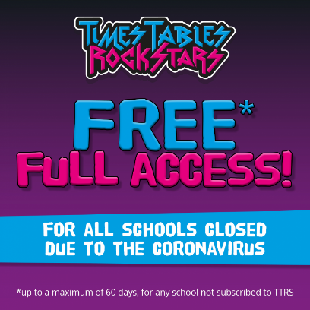

PhonicsPlay are free to use during the crisis, children can login at home without a subscription using these details.

See https://www.phonicsplay.co.uk/ for details
Username: march20
Password: home

Teach You Monster to Read App is currently *free* for a limited time – See more details here https://www.teachyourmonstertoread.com/blog  Apple App - https://apple.co/2V92VL5  Google Play - https://bit.ly/2cohkeR  Amazon Store - https://amzn.to/2PjLBiJ | 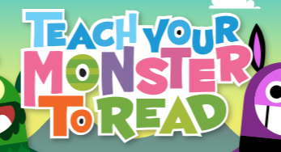

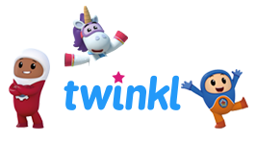 | Twinkl have created home learning and school closure packs, all free.  https://www.twinkl.co.uk/resources/covid19-school-closures

Pearson have offered free resources for home/school, this must be requested via the school but seems to include PowerMaths, BugClub, Abacus etc.
https://www.pearson.com/uk/educators/schools/update-for-schools/primary-support.html

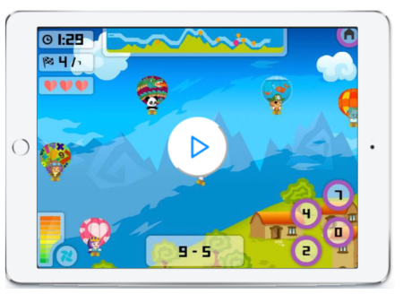 | Mangahigh have made their Maths and Coding resources free during the crisis – School must sign up first for this resource.  https://www.mangahigh.com/en-gb/blog/2020-03-06-free-access-schools-online-maths-coronavirus

Code.Org are continuing their free access to online coding resources, and also a weekly webcast where their team will teach children at home while school is closed including a weekly challenge to engage students of all abilities.  https://code.org/athome | 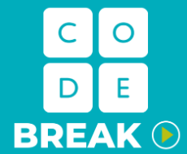

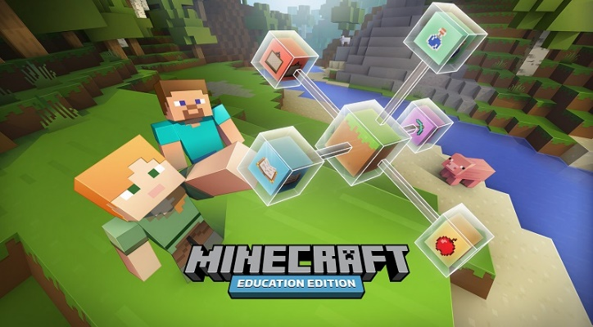 | Minecraft Education is currently free until June 2020, if you have a valid Office 365 account fill out this form, to request access till June. A Windows 10 device is required to  Run Minecraft Education.  https://education.minecraft.net/get-started/

The following list is various companies recommended by colleagues in the IT Educational industry that may prove useful:

Khan Academy
https://www.khanacademy.org
Especially good for maths and computing for all ages but other subjects at Secondary level. Note this uses the U.S. grade system but it's mostly common material.

BBC Learning
http://www.bbc.co.uk/learning/coursesearch/
This site is old and no longer updated and yet there's so much still available, from language learning to BBC Bitesize for revision. No TV licence required except for content on BBC iPlayer.

Futurelearn
https://www.futurelearn.com
Free to access 100s of courses, only pay to upgrade if you need a certificate in your name (own account from age 14+ but younger learners can use a parent account).

Seneca
https://www.senecalearning.com
For those revising at GCSE or A level. Tons of free revision content. Paid access to higher level material.

Openlearn
https://www.open.edu/openlearn/
Free taster courses aimed at those considering Open University but everyone can access it. Adult level, but some e.g. nature and environment courses could well be of interest to young people.

Blockly
https://blockly.games
Learn computer programming skills - fun and free.

Scratch
https://scratch.mit.edu/explore/projects/games/
Creative computer programming

Ted Ed
https://ed.ted.com
All sorts of engaging educational videos

National Geographic Kids
https://www.natgeokids.com/uk/
Activities and quizzes for younger kids.

Duolingo
https://www.duolingo.com
Learn languages for free. Web or app.

Mystery Science
https://mysteryscience.com
Free science lessons

The Kids Should See This
https://thekidshouldseethis.com
Wide range of cool educational videos

Crest Awards
https://www.crestawards.org
Science awards you can complete from home.

iDEA Awards
https://idea.org.uk
Digital enterprise award scheme you can complete online.

Paw Print Badges
https://www.pawprintbadges.co.uk
Free challenge packs and other downloads. Many activities can be completed indoors. Badges cost but are optional.

Tinkercad
https://www.tinkercad.com
All kinds of making.

Cbeebies Radio
https://www.bbc.co.uk/cbeebies/radio
Listening activities for the younger children.

Nature Detectives
https://naturedetectives.woodlandtrust.org.uk/naturedetectives/
A lot of these can be done in a garden, or if you can get to a remote forest location!

British Council
https://www.britishcouncil.org/school-resources/find
Resources for English language learning

Oxford Owl for Home
https://www.oxfordowl.co.uk/for-home/
Lots of free resources for Primary age

Big History Project
https://www.bighistoryproject.com/home
Aimed at Secondary age. Multi disciplinary activities.

Geography Games
https://world-geography-games.com/world.html
Geography gaming!

Blue Peter Badges
https://www.bbc.co.uk/cbbc/joinin/about-blue-peter-badges
If you have a stamp and a nearby post box.

The Artful Parent
https://www.facebook.com/artfulparent/
Good, free art activities

Red Ted Art
https://www.redtedart.com
Easy arts and crafts for little ones

The Imagination Tree
https://theimaginationtree.com
Creative art and craft activities for the very youngest.

Toy Theater
https://toytheater.com/
Educational online games

DK Find Out
https://www.dkfindout.com/uk/?fbclid=IwAR2wJdpSJSeITf4do6aPhff8A3tAktnmpaxqZbkgudD49l71ep8-sjXmrac

Activities and quizzes

Also the two below sites have been actively adding more various sites too:
https://chatterpack.net/blogs/blog/list-of-online-resources-for-anyone-who-is-isolated-at-home
https://hip2save.com/tips/free-educational-games-for-kids/

