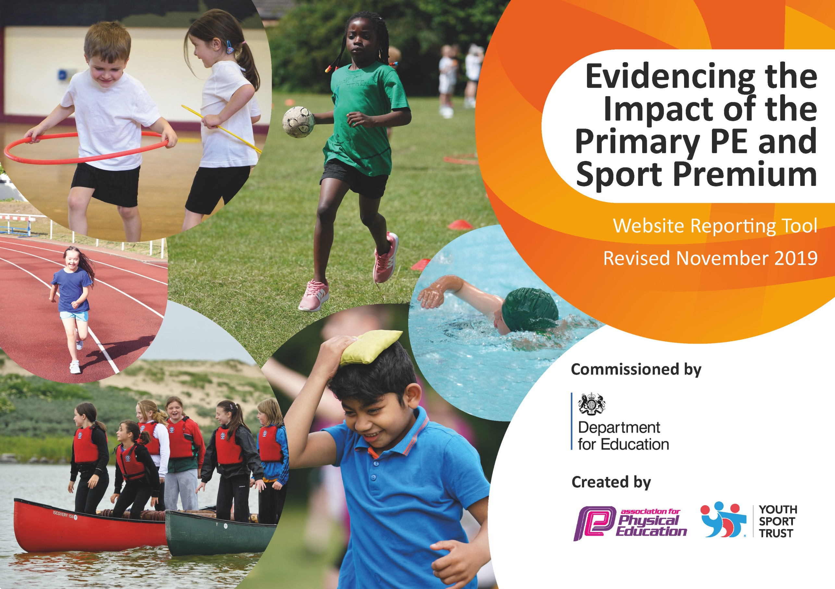
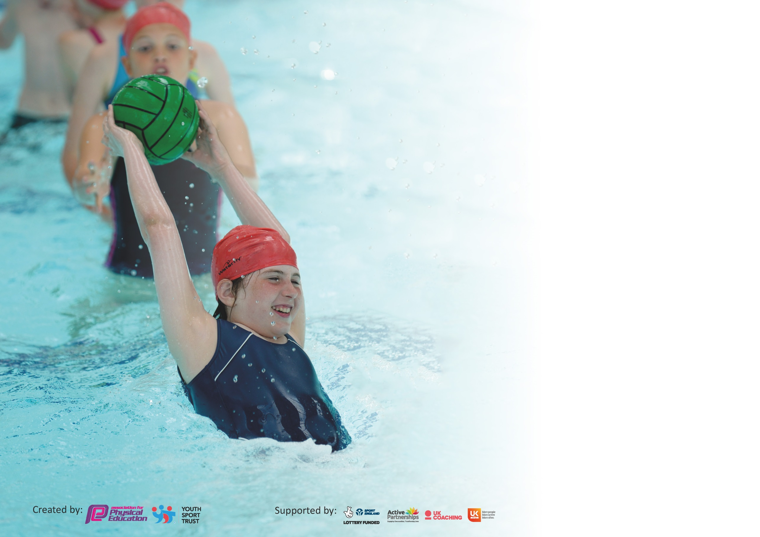

It is important that your grant is used effectively and based on school need. The Education Inspection Framework (Ofsted 2019 p64) makes clear there will be a focus on ‘whether leaders and those responsible for governors all understand their respective roles and perform these in a way that enhances the effectiveness of the school’.

Under the Quality of Education criteria (p41) inspectors consider the extent to which schools can articulate their curriculum (INTENT), construct their curriculum (IMPLEMENTATION) and demonstrate the outcomes which result (IMPACT).

To assist schools with common transferable language this template has been developed to utilise the same three headings which should make your plans easily transferable between working documents.

Schools must use the funding to make additional and sustainable improvements to the quality of Physical Education, School Sport and Physical Activity (PESSPA) they offer. This means that you should
use the Primary PE and Sport Premium to:

- Develop or add to the PESSPA activities that your school already offer
- Build capacity and capability within the school to ensure that improvements made now will benefit pupils joining the school in future years

Please visit gov.uk for the revised DfE guidance including the 5 key indicators across which schools should demonstrate an improvement. This document will help you to review your provision and to report your spend. DfE encourages schools to use this template as an effective way of meeting the reporting requirements of the Primary PE and Sport Premium.

We recommend you start by reflecting on the impact of current provision and reviewing the previous spend.

Schools are required to publish details of how they spend this funding as well as on the impact it has on pupils’ PE and sport participation and attainment by the end of the summer term or by 31st July 2020 at the latest.

We recommend regularly updating the table and publishing it on your website throughout the year. This evidences your ongoing self-evaluation of how you are using the funding to secure maximum, sustainable impact. Final copy must be posted on your website by the end of the academic year and no later than the 31st July 2020. To see an example of how to complete the table please click HERE.

Support for review and reflection - considering the 5 key indicators from DfE, what development needs are a priority for your setting and your pupils now and why? Use the space below to reflect on previous spend and key achievements and areas for development.

Key achievements to date until July 2019: | Areas for further improvement and baseline evidence of need:
Hartford Primary School has achieved three Platinum Awards for PE. This shows that PE has a high priority in school and that we provide a range of activities for all children to access.  At Hartford we aim to give children of all abilities access the chance to access activities that meet their needs. Our most able children are given high-quality coaching that leads to sporting success.  All children have high-quality PE lessons and the chance to be active for at least 30 minutes every school day. | We aim to provide extra sessions for children whose basic skills do not allow them to fully access the PE curriculum. Y5 and 6 children at Hartford will have Phys Kids Leaders training and a rota. This will focus on children who need extra help. Change 4 Life Champions will attend training provided by the Vale Royal School Sport Partnership. Targeted children will be invited to attend the C4L club and be involved in planning the activities they enjoy.  The PE curriculum will be developed and used for whole school improvement. The values taken from My Personal Best course will be taught through every PE lesson and also taught across the school.

Meeting national curriculum requirements for swimming and water safety.
What percentage of your current Year 6 cohort swim competently, confidently and proficiently over a distance of at least 25 metres?  N.B. Even though your pupils may swim in another year please report on their attainment on leaving  primary school at the end of the summer term 2020. | 98%
What percentage of your current Year 6 cohort use a range of strokes effectively [for example, front crawl, backstroke and breaststroke]? | 98%
What percentage of your current Year 6 cohort perform safe self-rescue in different water-based situations? | % No data available
Schools can choose to use the Primary PE and Sport Premium to provide additional provision for swimming but this must be for activity over and above the national curriculum requirements. Have you used it in this way? | Yes/No – We planned to do top-up swimming but it did not happen due to Covid-19

Action Plan and Budget Tracking
Capture your intended annual spend against the 5 key indicators. Clarify the success criteria and evidence of impact that you intend to measure to evaluate for pupils today and for the future.

Academic Year: 2018/19 | Total fund allocated: £19380 | Date Updated:01/07/2020
The funding allocated shows what was actually spent this year. The remaining money will be added onto next year to ensure the suggested next steps in each area can be completed.
Key indicator 1: The engagement of all pupils in regular physical activity – Chief Medical Officer guidelines recommend that primary school pupils undertake at least 30 minutes of physical activity a day in school |  |  |  | Percentage of total allocation:
 |  |  |  | 18%
Intent | Implementation |  | Impact
Your school focus should be clear what you want the pupils to know and be able to do and about  what they need to learn and to  consolidate through practice: | Make sure your actions to achieve are linked to your intentions: | Funding allocated: | Evidence of impact: what do pupils now know and what can they now do? What has changed?: | Sustainability and suggested next steps:
At Hartford Primary School we are very committed to ensuring that our pupils are as active as possible. We want children to understand why they should be active during the school day and ways they can achieve this. We will use the Active Heatmaps to help us find out what is working and what needs to improve. | We have received training regarding the recommended 60 active minutes from Youth Sport Trust & Vale Royal School Sport Partnership. The training has included sharing best practice in the active schools agenda through local case studies.  We have used the Active School Planner to create Heatmaps covering all classes and a range of target groups (including the least active, gender groups, disadvantaged etc).  - Our school has engaged in Vale Royal School Sport Partnership Subject Leaders Active Schools Development Group in order to develop actions for the areas identified by our Active School Planner Heat Maps.  - We are using 5-a-day fitness to provide children with a fun way to be active, to provide active breaks across the timetable or to bring focus to groups during lesson times  - We will ensure every child has the opportunity to get involved in extra-curricular activity whether at lunchtimes, playtimes or in after-school clubs  - Our Change 4 Life Sports club in years 3 & 4 will encourage children to take up physical activities and maintain healthy lifestyles  - Our school runs a recreational running programme called Golden Mile where pupils run or walk laps of our designated track  - We have developed PhysKids Play Leader roles who create activities to make lunchtimes more active. Our midday assistants have attended training to help them develop more activity at lunchtimes and to support our PhysKids Playleaders.  - We have engaged with the British Cycling balance biking programme Ready Set Set, Big Pedal and Bikeability training to improve pupils skills and confidence and support them and their families take up more active travel to and from school.  - Throughout school closure our school has continued to promote physical activity with it’s school community, reinforcing the message that children should take part in 60 minutes of moderate/vigorous activity each day.  - We have shared challenges each day to support the #StayHomeStayActive & #StayInWorkOut campaigns and have promoted the use of 5-a-day fitness, Go Noodle and Cosmic Yoga.  - For children in school we have maintained regular daily activity and shared this activity to inspire further engagement of those at home  - Mr. Cairns posted videos throughout the lockdown which promoted daily skills challenges.  - The School Sport Organising Crew researched healthy living and activity levels. They presented an assembly about this to the whole school. They were also planning to help Mr. Cairns to run Healthy Living Week in the Summer Term. | £3500 | The evidence base for this area is very difficult to present due to Covid-19. We did a questionnaire in the Autumn Term asking a range of questions about PE and activity levels. The follow up questionnaire could not be completed.  - The heatmap for the school was completed and this led to the subject leader completing an action plan. This is yet to be fully implemented or evaluated.  - 5 a day fitness is used across all classes in school and this is checked by the subject leader every half term.  - Extra clubs were planned for the 2nd half of the year but unfortunately could not take place.  - The Change 4 Life Training took place and the children were identified. Unfortunately it did not take place.  - The Golden Mile happens every week in every class. This is monitored by the PE subject leader.  - The Phys Kids Playleaders were all trained and the rota had started at lunchtimes. The impact was not fully assessed.  - Bikeability happened in the Autumn Term. 100% of the Y6 children left school with at least a level 1 certificate. 96% received a level 2.  - (9, 10 and 11) Hartford Primary School are proud of the amount of support it gave to families to continue to develop their fitness and skills during lockdown. Some of the videos were even shared by the Top Ya! App during National School Sport Week.  12. The assembly happened and gave children across the school a refresher on how and why we need to be active and lead a healthy lifestyle. This understanding would have been evaluated after Healthy Living Week during the Summer Term. | All of the successes this year can be continued next year as they were not fully developed and evaluated. Healthy Living Week will be planned in for the Autumn Term next academic year and further evaluations will take place.
Key indicator 2: The profile of PESSPA being raised across the school as a tool for whole school improvement |  |  |  | Percentage of total allocation:
 |  |  |  | 6%
Intent | Implementation |  | Impact
Your school focus should be clear what you want the pupils to know and be able to do and about  what they need to learn and to  consolidate through practice: | Make sure your actions to achieve are linked to your intentions: | Funding allocated: | Evidence of impact: what do pupils now know and what can they now do? What has changed?: | Sustainability and suggested next steps:
This year we aimed to use PE as a focus for whole school improvement. My Personal Best training for the subject leader led to discussions with the SLT about the values our children show in school. We aim to take values from this course and teach them across the school. The PE curriculum will be developed so specific values are taught during PE. | - We ensure our PE Subject Leader has appropriate support to develop our PE & School Sport offer and lead our teachers effectively. Our PE Subject Leader will attend regular training and receive focused support from Vale Royal School Sport Partnership & Youth Sport Trust trainers.  - Welcome an athlete role-model to school to inspire our pupils to increase their participation in PE & School Sport.  - Staff have attended training which focuses on increasing attainment in Maths through physical activity in order to maximise the opportunities for our pupils to be physically active  - We are included in the Youth Sport Trust’s ‘My Personal Best’ programme which involves training our staff to adopt the explicit teaching of life skills such as co-operation, resilience and responsibility through Physical Education. This learning will also be transferred into other lessons, their life in school and to their wider lives.  - We are included in the Shooting Stars Active Play through Storytelling & After School Club training provided by the Football Association. This training course and supporting resources have been developed to support ‘the beginner girl’ aged 5 to 8 in developing their physical literacy, confidence and speaking & listening skills through the medium of creative play and storytelling. It is expected that through the programme, these girls will grow in confidence which will lead to them becoming more physically active in the playground and engaging in a wider range of activities. | £1200 | - Membership of the VRSSP was paid and ensures the PE co-ordinator and all the staff have access to all the training necessary to keep up to date with developments in PE.  - This unfortunately did not happen as it was planned for the Summer Term.  - Active Maths ran a staff meeting to re-train staff in the use of the website. Staff do an active maths lesson at least once a fortnight.  - This whole school development of PE worked very well. The PE curriculum was re-written to focus on the values taken from My Personal Best Training. Whole school values were discussed in assemblies and lessons to develop the children. The impact was unfortunately not fully assessed but will be in the Autumn Term.  - These did not happen as they were planned for the Summer Term. They will hopefully take place next academic year. | Our last three vales were not taught across the school. These will be carried on next year.  The impact of the change will be assessed using staff and pupil questionnaires.  The 2 courses that were missed will be done and evaluated next year.  Another role-model will be booked in, hopefully during Healthy Living week.

Key indicator 3: Increased confidence, knowledge and skills of all staff in teaching PE and sport |  |  |  | Percentage of total allocation:
 |  |  |  | 9%
Intent | Implementation |  | Impact
Your school focus should be clear | Make sure your actions to | Funding | Evidence of impact: what do | Sustainability and suggested
what you want the pupils to know | achieve are linked to your | allocated: | pupils now know and what | next steps:
and be able to do and about | intentions: |  | can they now do? What has
what they need to learn and to |  |  | changed?:
consolidate through practice:
Hartford aim to use the PE & Sport Premium to ensure the high-quality teaching of PE across the school. Mr. Cairns teaches one PE lesson to every class in school. The class teacher then teaches the other. A questionnaire and observations will establish which staff members need support in which areas of PE and this will be provided by Mr. Cairns or the VRSSP. | We ensure our teachers have quality training specific to their age phase which develops exciting, progressive and inclusive teaching and learning in PE.  Staff attend Early Years (centred on the YST Health Movers programme), KS1 training (centred on the YST TOP Start research and resource), KS2 Training (centred on the YST TOP Sport resource), Inclusion training and Health & Safety training.  Teachers who have attended training in recent years are able to access ‘Next Steps’ training which will help them develop their practice further.  Our school has the support of a specialist PE teacher (our PE & School Sport Coordinator) who co-delivers PE lessons with staff who have identified that they would benefit from additional support.  Our staff attend training in the FA Primary Teachers Award, Shooting Stars Active Play through Storytelling & After School Club training provided by the Football Association.  Our staff are engaged with the Royal Opera House/Royal Ballet ‘Create: Dance’ project which will see increase confidence, competence and a wider range of resources in school to support the teaching of dance. | £1800 | Staff engaged with a range of training across the school year and more was planned for the 2nd half of the year. This will now be planned in for next year.  The impact of the training was difficult to establish as staff had very little time to teach PE after the training had happened.  The specialist PE teacher from the local high school was booked to come in during the Summer Term. This will be re-booked.  Our staff did not attend training in the FA Primary Teachers Award, Shooting Stars Active Play through Storytelling & After School Club training provided by the Football Association. These will be re-booked.  Mr. Cairns attended the training by the Royal Ballet. He had just started teaching this curriculum across the school. This will continue next year and be fully evaluated. | Unfortunately, the impact of all the training could not take place due to courses being cancelled or not having enough time after training for the impact to be measured.  These will all continue into the next academic year.
Key indicator 4: Broader experience of a range of sports and activities offered to all pupils |  |  |  | Percentage of total allocation:
 |  |  |  | 10%
Intent | Implementation |  | Impact
Your school focus should be clear | Make sure your actions to | Funding | Evidence of impact: what do | Sustainability and suggested
what you want the pupils to know | achieve are linked to your | allocated: | pupils now know and what | next steps:
and be able to do and about | intentions: |  | can they now do? What has
what they need to learn and to |  |  | changed?:
consolidate through practice:
At Hartford we aim to give our children access to a range of sports activities alongside more traditional sports. Children have taken part in lacrosse, orienteering, boccia, goalball, Drums Aloud, cross country, the Royal Ballet curriculum and many more. We will continue to use questionnaires developed with our Y6 School Sport Organising Crew to ensure we are providing for the needs of all the children. | We aim to provide a broader range of sports and activities to engage all children. This means that we will seek the views of our children before developing programmes such as extra-curricular clubs to ensure that they are in an activity which maximises engagement of all groups, at a time/venue which best engages those we want to engage and are rewarding to take part in.  Our PE curriculum is designed to engage all learners and ensure they have the skills and confidence to take part in a wide range of activities.  School staff are trained to create activities in PE and extra-curricular activity which meet the needs of every learner in order to support their progress.  Throughout COVID-19 our pupils have been able to continue to engage in a wide range of inclusive physical activities through the daily challenge programme. We have used our PE curriculum as part of our recovery curriculum for returning students or for vulnerable children/those of key worker and have used lessons to build confidence and reinforce social distancing messages. | £2000 | A questionnaire took place which identified the children who are the least active, the least able and those not engaging with school sport. These children were asked which sports they would like to take part in, especially during a C4L club. Unfortunately, this could not happen.  A lot of extra equipment was needed to ensure that the curriculum could still happen when children came back to school. This allowed for all children to have access to equipment when other items were being cleaned.  The PE curriculum after we returned was very successful. It focused on fitness activities and basic skills using planning from the VRSSP. All this was done in a physically-distanced was to ensure safety and confidence. | The curriculum may need to be adapted for the current situation in September. This may need more PE equipment and a further focus on safety and confidence. The children will need a lot of support to settle back into the school routine and the staff will need further training to ensure the PE curriculum can still provide a range of sports and activities. These sports may not be able to take place against other schools so the co-ordinator will need to be creative to ensure these experiences still take place.

Key indicator 5: Increased participation in competitive sport |  |  |  | Percentage of total allocation:
 |  |  |  | 8%
Intent | Implementation |  | Impact
Your school focus should be clear | Make sure your actions to | Funding | Evidence of impact: what do | Sustainability and suggested
what you want the pupils to know | achieve are linked to your | allocated: | pupils now know and what | next steps:
and be able to do and about | intentions: |  | can they now do? What has
what they need to learn and to |  |  | changed?:
consolidate through practice:
This is an area of real strength for Hartford again. We offer a range of competitive chances for every child in school ranging from personal challenges, intra-school competitions and intra-school competitions. Each child engages at the correct level for them. Our most-able children are given extra tactical and sport-specific coaching to prepare them for competitions. This will all continue this year. | - Teachers attend a range of sport specific training courses to help us broaden the range of competitions we provide for our children. Our staff will attend training focused on the School Games formats for intra and inter school competition  - We take part in a wide variety of competitive sports both within school and against other schools. By planning a range of intra-school competitions which can be accessed by all groups in school, selecting pupils and teams to take part in local inter-school competitions against other schools (both within the local cluster and across the Vale Royal School Sport Partnership), we aim to be fully involved in the School Games and other schools’ competitions  - Our school takes part in an annual School Games Festival which takes place to celebrate National School Sport Week. We engage with a wide-range of festivals and events which cater for many different children.  - We annually apply for a School Games Mark award and strategically plan to develop our offer of competitive sport in line with the criteria. The School Sport Organising Crew help to ensure that the offer is fit for purpose and is targeted at every child in school.  - Throughout COVID-19 our school has been able to engage with the programme of daily challenges, National School Sport Week at Home and also the county Virtual School Games, all of which aimed to reflect the competition programme familiar to our children. Each activity has focused on achieving a personal best in order to promote resilience, determination, self-belief and to build confidence. | £1500 | 1)Some of this sport-specific training was planned for the Summer Term. It will be re-booked.  2) Hartford attended every competition that was planned by the local high school and the VRSSP. Every child in Y5 and 6 either took part in a competition or was planned to in the Summer Term. Teams reached the County Final in boys and girls football.  Intra-school competition took place at lunchtimes. 80% of KS2 children took part in these dodgeball competitions organised and run by the Y6 SSOC.  3) National School Sport Week had to be done online die to lockdown. Videos were posted every day by Mr. Cairns and the VRSSP via Twitter.  4) The School Games Mark could not be applied for this year. Hartford did achieved the School Games Mark ‘Recognition’ and ‘Virtual’ Award for their work during lockdown.  5) When the children came back to school in the Summer Term, Mr. Cairns ensured that they took part in a school-wide personal challenge and a sports-day style event where different bubbles competed remotely against each other. | The competition program at Hartford is fully sustainable and happens every year due to the organisation by the VRSSP.  Mr. Cairns ensures access to these competitions at the appropriate level for every child and will continue to do so.

Signed off by
Head Teacher: | Mair Fairweather
Date: | 23/07/2020
Subject Leader: | Tom Cairns
Date: | 01/07/2020
Governor: | Julia Hughes
Date: | 23/07/2020

