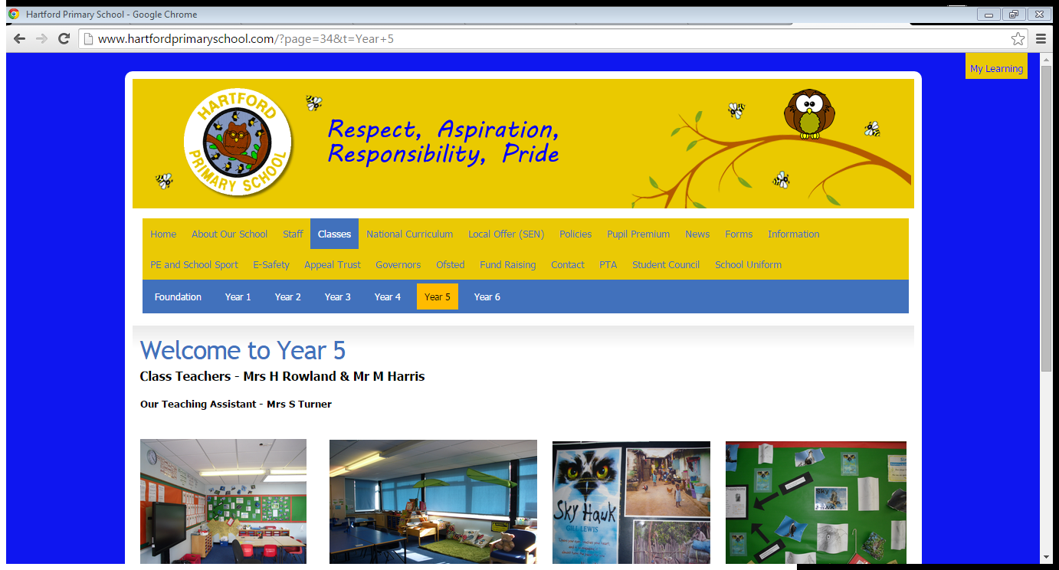
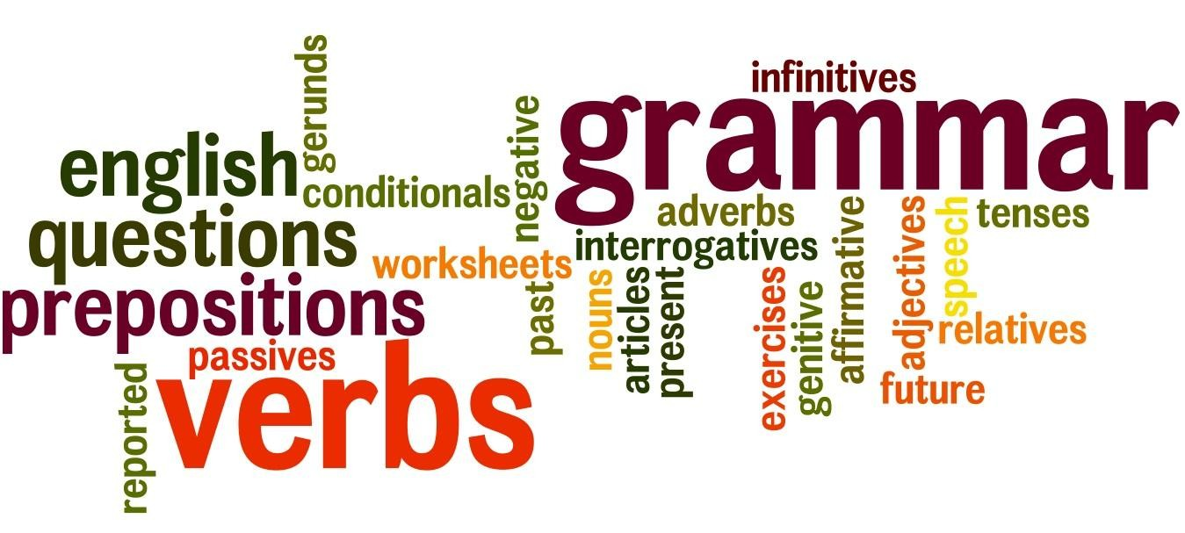

 | Grammatical  Feature: |  | Definition: |  |  | Example:
Active Voice When the subject of a verb carries out David Beckham scored the penalty. an action.
Adjective A word that describes a noun. e.g. the cat is very happy
Adverbs A word that describes a verb, an The beetle is extremely small. adjective or another adverb. The cat moved stealthily.
It nearly always answers the questions: How? When? Where? or Why?
Most adverbs in English end in –ly and come from adjectives.
Antonyms Words which mean the opposite to The antonym of up is down each other. The antonym of tall is short
The antonym of add is subtract
Apostrophe |  |  | Punctuation showing possession or missing letters.  the words ‘the’, ‘a’ or ‘an’ |  | Contractions:  Is not = isn’t Could not = couldn’t  Showing Possession:  With nouns (plural and singular) not ending in an s add 's:  the girl’s jacket, the children's books  With plural nouns ending in an s, add only the apostrophe:  the guards' duties, the Jones' house  With singular nouns ending in an s, you can add either 's or an apostrophe alone:  the witness's lie or the witness' lie (be consistent)
Articles
Brackets Punctuation Used for additional To clarify information:
information or explanation. Jamie's bike was red (bright red) with a yellow stripe.

For asides and comments:
The bear was pink (I kid you not).

To give extra details:
His first book (The Colour Of Magic) was written in 1989.
Capital Letters Uppercase letters. Capital letters are used:

TO BEGIN SENTENCES
TO BEGIN PROPER NOUNS TO BEGIN WORDS IN TITLES
TO BEGIN WORDS OF EXCLAMATION TO BEGIN WORDS HE, HIM, HIS WHEN REFERRING TO GOD
TO WRITE THE PRONOUN ‘I’

Clauses A clause is a group of words which Main clause: My sister is older than me. does contain a verb; it is part of a
sentence. Subordinate: My sister is older than me and she is very annoying. There are two kinds of clauses:
1. A main clause (makes sense Embedded clause: My sister, who is very annoying, is older than on its own) e.g.: Sue bought a me.
new dress.
2. A subordinate clause (does not make sense on its own; it depends on the main clause for its meaning)
Colon Punctuation which indicates that an On School journey you will need to bring: a waterproof coat, example, a list, or more detailed willies, warm jumpers and any medication.
explanation follows.
Marvin was stunned: he had never seen a firework display like it!
Command A sentence that tells someone to do Do the washing up. something.
Commas Punctuation which shows a pause, Jenny’s favourite subjects are maths, literacy and art.
separates clauses or separates items in Joe, Evan and Mike were chosen to sing at the service.
a list. The giant had a large head, hairy ears and two big, beady eyes.

Where the phrase (embedded clause) could be in brackets:
The recipe, which we hadn't tried before, is very easy to follow.

Where the phrase adds relevant information:
Mr Hardy, aged 68, ran his first marathon five years ago.

To mark a subordinate clause:
If at first you don't succeed, try again.
Though the snake was small, I still feared for my life.

Introductory or opening phrases:
In general, sixty-eight is quite old to run a marathon. On the whole, snakes only attack when riled.

Fronted verbs:
Unfortunately, the bear was already in a bad mood
and, furthermore, pink wasn't its colour.
Complex A sentence with a main clause and at Although it was late, I wasn’t tired.
sentences least one subordinate clause.
My Gran (who is as wrinkled as a walnut) is one hundred years
old.
Compound A sentence with two main clauses It was late but I wasn’t tired.
sentences joined together with a connective like:
and, but, or.

connectives A word or phrase that links clauses or Cause and effect: because, as a result of, then, therefore, sentences. accordingly, for

Choices: or, on the other hand, either or, another, otherwise, alternatively

Compare and contrast: but, or, however, likewise, otherwise, similarly, yet, on the other
hand, not withstanding, the opposing view

Conclusions: the findings are, in summary, hence, thus, on the whole, in the
main, in conclusion

Linking: moreover, besides, in the same way, likewise, what is more,
additionally, as well as

Order: finally, after this, next, then, firstly, secondly, presently, subsequently, eventually, then
Consonant All letters except: a, e, i, o, u.
Contraction A word that is hortened by missing out don’t
some letters. wouldn’t
Dash Punctuation which indicates a stronger I stood – waiting – waiting – waiting. pause than a comma. Can be used like
a comma or bracket to add The woman – only 25 years old – was the first to win a gold medal
parenthesis. for Britain.
Dialogue A conversation between two or more “Who’s there?” asked Marvin.
people. “Doctor”, replied the mysterious man behind the door.
“Doctor Who?” Marvin enquired.
“Exactly…” came the ominous response.
Direct speech When you write down the actual “Who’s there?” asked Marvin.
words that are spoken and use speech marks.
Ellipsis Punctuation used to show a pause in A pause in speech:
someone’s speech or thoughts, and to “The sight was awesome… truly amazing.”
build tension or show that a sentence
is not finished. At end of a sentence to create suspense:
Mr Daily gritted his teeth, gripped the scalpel tightly in his right
hand and slowly advanced…
Exclamation A sentence which shows someone What a triumph!
feels strongly about something.
Exclamation Punctuation which shows something is What a triumph!
mark being exclaimed or said with feeling or I’ve just about had enough!
surprise. Wonderful!
First person When the writer speaks about himself My family all went to the park. We all loved it, me especially. I
or herself. always love the slide. Only ‘I/we/me/us’ are used as
pronouns when writing in the first
person.

Formal language | Language which follows the traditional
 | rules, without using casual or
 | colloquial vocabulary
Full stop Punctuation which shows the end of a Terry Pratchett's latest book is not yet out in paperback. sentence or an abbreviation. I asked her whether she could tell me the way to Brighton.
Future tense Writing about what will happen. Next week, Marvin will be going to Secondary school. He will have to wear a blazer and tie!
We usually place will in front of verbs
when writing in the future tense.
Homophones Words which sound the same but are Their, there, they’re
spelt differently and have different I, eye meanings. Our, are
To, too, two
Hyphen Punctuation which joins one or more Happy-go-lucky words or adds a prefix to a word.
Idiom Phrases in a language which do not ‘I’m feeling blue’ – I’m feeling sad
mean exactly what they say. ‘a piece of cake’ – easy
‘raise the roof’ – make a lot of noise/celebrate
Informal Language which does not follow the Init
language traditional rules. It can be a use of Wah gwan
colloquial word or expressions.
Metaphor Compares different things by saying Marvin became a lion – frightened of nothing. one thing is another. The teacher’s shouting was a tornado of abuse.
Noun A part of speech which names a thing Common noun: everyday things: cars, toothbrushes, trees,… –
or person. and kinds of people: man, woman, child …
Nouns can be classified into four
different types: common nouns, Proper noun: particular people and places: Jim, Betty, London... –
proper nouns, collective nouns, and some ‘times’: Monday, April, Easter… It always begins with a
abstract nouns. capital letter.

Collective noun: A group or collection of people or things: army,
bunch, team, swarm…

Abstract noun: Cannot actually be seen, heard, smelt, felt or tasted: sleep, honesty, boredom, freedom, power …
Object The person or thing that the action or verb is done to.
Paragraph ‘Chunks’ of related thoughts or ideas.
They make reading easier to
understand.
A new paragraph usually means a change of topic, idea, time, place or argument.
Passive voice When a subject or verb has an action A window was smashed. done to them.
Often, the subject is not even
mentioned.

Past tense Tells you about what happened in the Yesterday, Marvin bought a new PSP. past.
Regular past tense verbs end in ‘ed’. Juliana walked down the road.
Personification Giving human qualities to animals or The Sun smiled on the World. objects.
The birds sung their beautiful song.
Phrase Part of a sentence which does not In an adjective phrase, one or more words work together contain a verb and does not make to give more information about an adjective.
sense on its own. • so very sweet
• earnest in her desire
• very happy with his work

In an adverb phrase, one or more words work together to give more information about an adverb.
• especially softly
• formerly of the city of Perth
• much too quickly to see clearly

In a noun phrase, one or more words work together to give more information about a noun.
• all my dear children
• the information age
• seventeen hungry lions in the rocks
Plurals More than one person, place or thing. Most nouns are made into plurals by adding –s:
Three bikes

Some nouns ending in –o are made into plurals by adding –es:
Two mangoes

Most nouns ending in hissing, shushing or buzzing sounds are made into plurals by adding –es:
Ten dresses

For words ending in a vowel and then –y, just add –s:
Eight turkeys

For words ending in a consonant and then –y, change -y to -i and add –es:
Five flies

Most nouns ending in -f or-fe change to -ves in the plural:
Six halves
Prefix A letter, or group of letters, added to Adding ‘un’ to happy – unhappy the beginning of a word to change its Adding ‘dis’ to appear – disappear meaning. Adding ‘re’ to try – retry
Present tense Tells you about what is happening I am writing a SPAG Glossary!
now.
Verbs often ends with ing in present tense.

Preposition Words which show the relationship About, above, across, after, against, along, amid, amidst, between two things. among, amongst, before, behind, below, beneath, beside, They often tell you where one thing is between, betwixt, beyond, by, down, during, except, for, as opposed to another. from, in, into, near, of, off, on, over, round, since, though,
till, to, towards, under, underneath, until, unto, up, upon, with, within, without.

Examples: Tom jumped over the cat.
The monkey is in the tree.
Pronoun Words used to avoid repeating a noun. I, you, me, he, she, it, you, him, her, mine, yours, his, hers, its we, they, us, them, ours, yours, theirs
Question A sentence that asks something. Who else will be there?
Question mark Indicates a question/disbelief. Who else will be there?
Is this really little Thomas?
Reported speech When you write what people say, “I feel sick” said Ben to Bill.
thing or believe without using speech
marks. would change to this:

Be careful: you often have to change Ben told Bill that he felt sick. the tense or some words.
Root word The simplest form of a word that help is a root word prefixes or suffixes can be added to .
It can grow into:
helps helpful helped helping helpless unhelpful
Second person When the writer speaks to the reader. You are reading a SPAG Glossary and I hope you are finding it useful.
The word ‘you’ is often placed before
verbs.
Semi colon Punctuation used in place of a To link two separate sentences that are closely related: connective. The children came home today; they had been away for a week. It separates two complete sentences
which are closely related and can be In a list:
used in lists of phrases. Star Trek, created by Gene Roddenberry; Babylon 5, by JMS;
Buffy, by Joss Whedon; and Farscape, from the Henson Company.
Sentence A sentence contains at least a subject Short example: Walker walks. A subject is the noun that is doing and a verb. the main verb. The main verb is the verb that the subject is doing. A sentence may convey a statement, In English and many other languages, the first word of a written question, command or exclamation. sentence has a capital letter. At the end of the sentence there is a
full stop or full point
Simile Compares two or more things, usually The water was as hot as lava.
using the words ‘like’ or ‘as’.
He was as scared as a mouse.
Simple sentence A one clause sentence. He walked to the park.

Speech marks Punctuation marks used in pairs ( “ ”) For direct speech:
(inverted to indicate: Janet asked, "Why can't we go today?"
commas)
• quotes (evidence). For quotes:
• direct speech The man claimed that he was “shocked to hear the news”.
• words that are defined, that
follow certain phrases or that For words that are defined, that follow certain phrases or that
have special meaning. have special meaning:
'Buch' is German for book.
The book was signed 'Terry Pratchett'.
The 'free gift' actually cost us forty pounds.
Standard English The form of English which follows formal rules of speech and writing.
Statement A statement is a sentence which gives Paper is made from trees. information.
Subordinate A clause which does not make sense Sue bought a new dress when she went shopping.
clause on its own, but gives extra information *‘when she went shopping’ is the subordinate clause as it would
to the main clause. not make sense without the main clause.
Subject The person or thing that carries out the action or verb.
Suffix A letter, or group of letters, added to Adding ‘ish’ to child – childish the end of the word to change its Adding ‘able’ to like – likeable meaning. Adding ‘ion’ to act – action
Synonym Words which have the same, or nearly Synonyms for:
the same meaning as each other.
Bad - awful, terrible, horrible Happy - content, joyful, pleased Look - watch, stare, glaze
Walk - stroll, crawl, tread
Third person When the writer speaks about He walked to the shops because he wanted to taste the new someone or something else. chocolate bar.

The pronouns ‘he/she/it/they/him/ her/it/them’ are used when writing in the third person
Vowel The letters: a, e, i, o, u.
Verbs A ‘doing’ word. The boy was playing football.

The crowd clapped as One Direction took the stage.
Word family | The group of words that can be built  from the same root word | Builds, building, builder, built, rebuild, rebuilt

